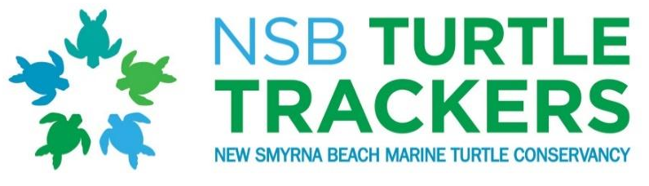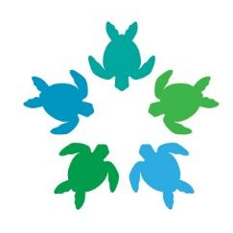
Volunteer Application

P.O. Box 44, New Smyrna Beach, FL 32168
Website: nsbturtletrackers.org
Email: nsbttsecretary@gmail.com

*New Volunteer Application Fee $15.00 (t-shirt included)
(not applicable to returning active volunteers)

____ Check included.

____ Electronic (nsbturtletrackers.org, Donate, $15)

____ Venmo (link on website, under donate)

Name: _________________________________________ Date of Birth: _______________
Address: ____________________________________________________________________
Phone (Home): ________________________ (Cell): _______________________________
Email address: _______________________________________________________________
T-shirt size: __________________________
Emergency Contact Information:
Name: _________________________________________ Relationship: __________________
Best phone #: ___________________________ Alternate #: ___________________________
What interests you about volunteering with New Smyrna Beach Turtle Trackers Marine Turtle Conservancy (“NSBTT”) __________________________________________________ _____________________________________________________________________________
All members are encouraged to help throughout the year to educate the public about marine turtle conservation and the NSBTT organization.
As a NSBTT volunteer, you will be expected to participate in a minimum of 4 activities (see list below), along with attendance at the annual Season Kick-off and Season End-of-Year Meetings.
Please check any areas of interest:
□ Beach Clean Ups: NSBTT has adopted a one mile stretch of New Smyrna Beach from Marianne Clancy Park to 13th Ave. Volunteers are needed to help keep this mile clean throughout the year and are scheduled approximately once a month.
□ Education Events: Educational events in local schools and organizations, at Marine Discovery Center, and as part of the NSB Get to Know Your Island program are a few of the educational events NSBTT participates in throughout the year
□ Community Events/Fundraising: Community involvement in Turtle Day at the Marine Science Center, Seaside Fiesta on Flagler, Crimson Cares Tips for Turtles, the NSB Christmas Parade are a few of the opportunities NSBTT participates in to educate the public about our organization. Fundraising is mainly through our Adopt-a-Nest Program.
□ Sea Turtle Stranding Team: Volunteers respond to dead, sick, and injured sea turtles that wash ashore and complete reports and/or transport live turtles to the Marine Science Center rehabilitation facility in Ponce Inlet.
To be added to this team, volunteers for this activity MUST:
- Be at least 18 years of age.
- Attend a biannual FWC Stranding/Salvage Workshop
□ Nesting Survey Team: (This team has limited availability with a current wait list. Please check this box if you would like to be added to the Survey Team Wait List. During your first year as a new volunteer, participation in education and community events will better prepare you to be considered as a future member of the survey team.)
Volunteers dedicate at least 2 mornings each week from May-September, undergo extensive training, and work in accordance with an FWC permit to assist in sea turtle monitoring on the New Smyrna Beaches under the guidance of the Habitat Conservation Plan (HCP) of Volusia County. Survey Team volunteers MUST:
- Be at least 18 years of age.
- Attend annual HCP Training (April) and a biannual FWC Nesting Workshop (March)
- Attend ALL monthly survey meetings (excused absences only)
- Have a valid Florida driver’s license (required to operate county vehicles)
- Be physically fit, including ability to work in extreme heat (at times up to 6 hours), dig large amounts of sand by hand, rake long turtle crawls, use heavy mallets to drive nest stakes into the ground, take measurements, and record accurate scientific information.
By my signature below, I certify that:
- I understand and acknowledge that my participation in NSBTT activities is purely voluntary.
- The information provided above is complete and accurate.
- I meet the participation criteria, if applicable, and will abide by all requirements set forth by the NSBTT for those activities in which I participate.
- I agree to “hold harmless” all the directors/officers of the NSBTT from any and all liabilities or damages, including physical injury, arising from my voluntary participation in NSBTT programs and activities. I further agree to hold harmless Ecological Associates, Inc. (EAI) and Volusia County, their administrators, officers, employees, agents, divisions, subsidiaries, and members, from any and all liabilities or damages, including personal injury, arising from my voluntary participation in sea turtle nesting surveys. This release of liability is intended to be as broad as allowable under the laws of Florida.
I, _________________________________ (please print your name), certify that I have read and understand the conditions of my participation in the New Smyrna Beach Marine Turtle Conservancy (NSBTT) and acknowledge that, but for my voluntary execution of this release of liability, the NSBTT would not allow me to participate, in any capacity, in activities affiliated with or sponsored/supported by the NSBTT.
Signature: _________________________________________ Date: _____________________
*Please return this application via mail or email to:
NSB Turtle Trackers
P.O. Box 44
New Smyrna Beach, FL 32168
Email: nsbttsecretary@gmail.com

Thank you for your support and we look forward to working with you soon!

